Batch Deposits - Documentation

Exported on Sep 16, 2020

Table of Contents

1 Navigating to Batch Deposits 3
2 Searching Batch Deposits 4
3 Adding a Batch Deposit 5
3.1 Creating a Batch 5
3.2 Batch Payment Details 5
3.3 Adding and Updating Batch Items 6
3.3.1 Batch Item Fields 7
3.3.2 Post and Commit Actions 8
3.4 Adding Items by Copy Existing 9
3.4.1 Copy to an existing payment line 10
3.4.2 Payment amounts when copying an existing payment line 10
3.5 Add Items by Auto Split 10
3.5.1 Create a new line 10
3.5.2 Add to an existing line 12
4 Working with Batch Items 15
4.1 Batch Item Variances 15
4.2 Payment Line and Batch Item Actions 16
5 Closing a Payment Batch 17
5.1 How to close a Payment Batch 17
5.2 What happens when a Payment Batch is closed? 17
5.3 Payment Line Item Transaction Fields 17
6 AR View 19
6.1 Searching for Clients 19
6.2 Viewing Client and Location Details 19

Navigating to Batch Deposits
ManuConnect > Main Menu > Batch Deposits:
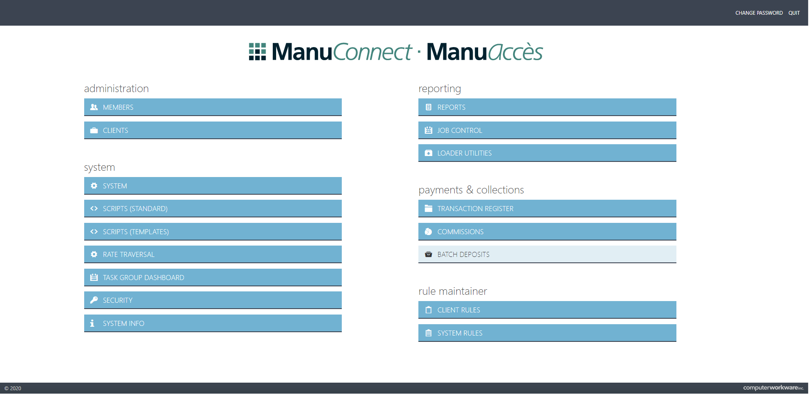

Searching Batch Deposits
The main search screen provides parameters to filter the available Batch Deposits. By default, all are displayed and sorted by the most recent batches.
Search results allow for sorting, paging and selecting Batch Deposits:
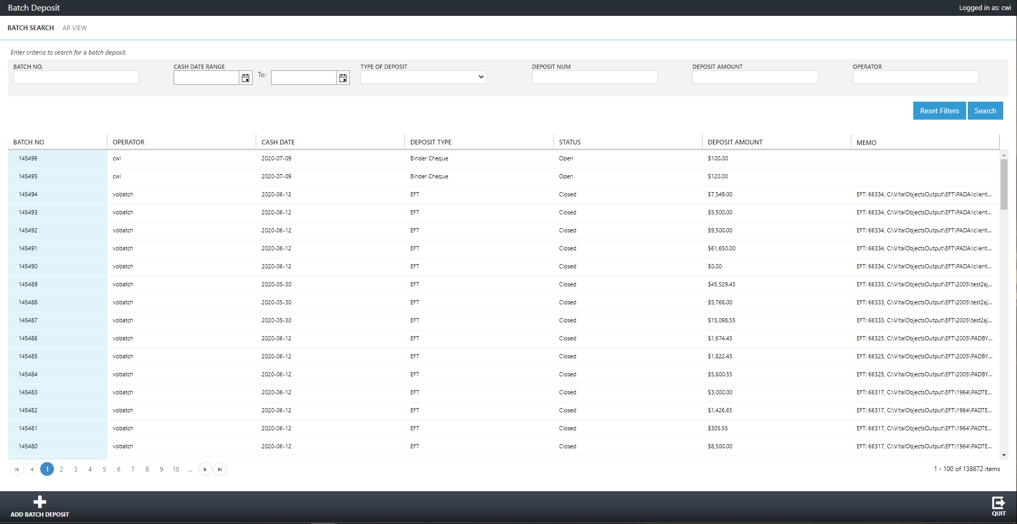

Adding a Batch Deposit

Creating a Batch
Each page contains an add icon in the lower left corner to display the add screen:

The add screen allows for selecting the type, category, currency, cash date, total batch amounts and any memo data:
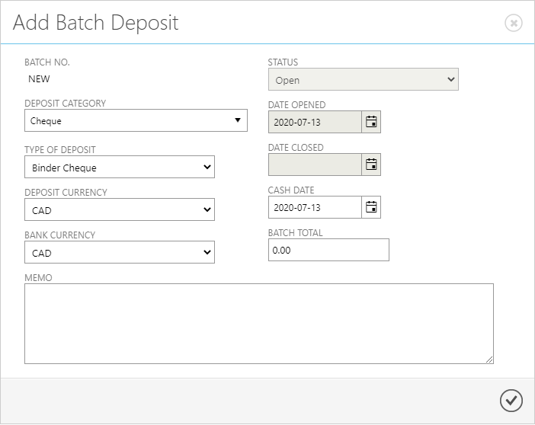

Batch Payment Details
The batch deposit details screen allows for:
- Editing of existing batch details (same details as found on the "add payment batch" screen)
- Viewing the totals of the batch, system and reversals
- Viewing the batch variance: Batch Total (entered on the batch details) - System Total (summation of each payment line) - Reverse Total (summation of any reversed payment lines)
- Closing a batch
- Copying existing batch items
- Adding batch items
- Reversing batch items
- Splitting batch items

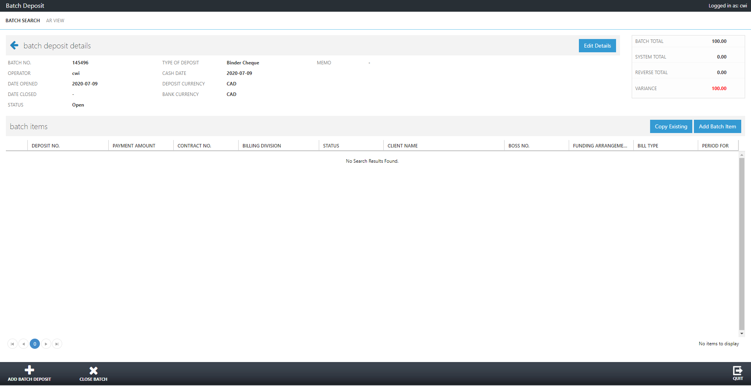

Adding and Updating Batch Items
Select "Add Batch Item" from the payment batch details screen to display the following screen:
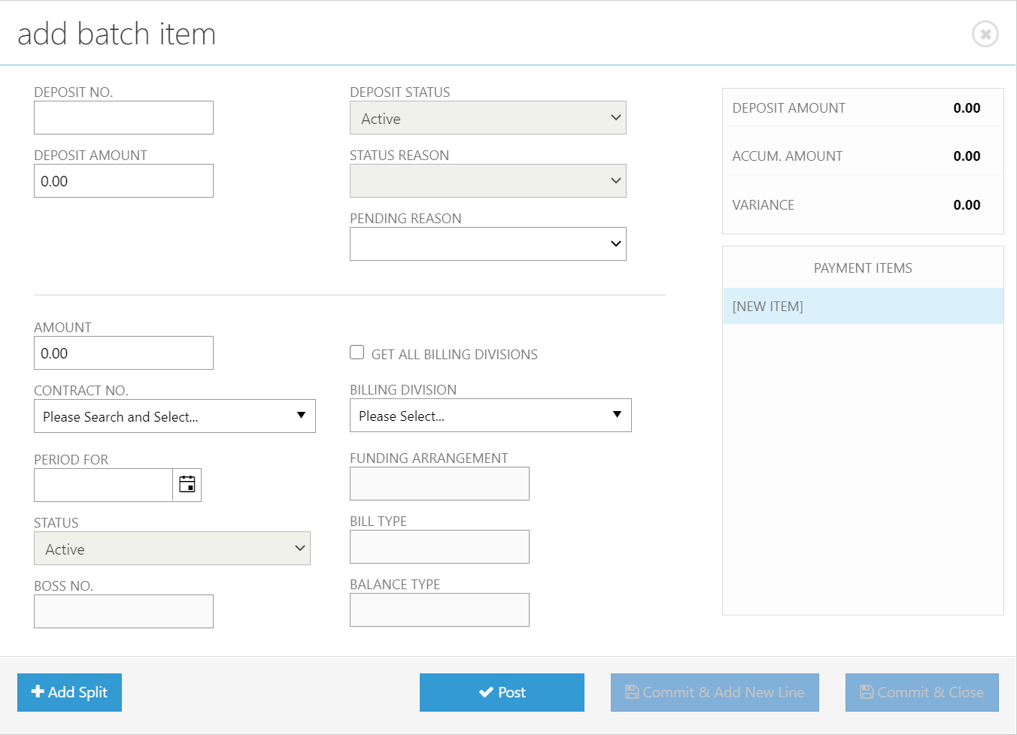

Batch Item Fields
Payment Line
Deposit No. | Describes the payment line (if the batch item is split, then this field will be used to describe each batch item).
Deposit Status | A read-only deposit status of the payment line. The deposit status of the batch item is controlled by actions throughout the payment batch.
Deposit Amount | The total of the payment line (if the batch item is split, then this amount will total all batch item amounts).
Status Reason | A read-only status reason of the payment line. The status reason of the batch item is controlled by actions throughout the payment batch.
Pending Reason | A list of pending reasons for the payment line.
Payment Line Item
Amount | The batch item amount (if the batch item is split, this amount is used in a summation of all batch items of the same payment line).
Contract No. | A list of Clients. It is a searchable dropdown which can be filtered by the Client name and number.
Get All Billing Division | When checked, the appropriate active Class Plan Links and Client Plan Benefits are ignored.
Billing Division | A list of Locations of the selected Client. It is a searchable dropdown which can be filtered by the Location name and number.
Period For | This is a date field saved for the batch item. The date value is defaulted from the selected location's account First In First Out (FIFO) Bill Date field.
Funding Arrangement | A read-only field retrieved from the first matching Client Plan Benefit (using the Client Policy Number) - AdminTypeCd.
Status | A read-only status of the batch item. The status of the batch item is controlled by actions throughout the payment batch.
Bill Type | A read-only field retrieved from the first matching Client Plan Benefit (using the Client Policy Number) - BillingTypeCd.
Boss No. | A read-only field retrieved from the selected location using the Funding Arrangement to determine the appropriate ASO or Insured Contract Number to display.
Balance Type | Displays the balance type of the fetched Location Account (MLI Billed/Client Billed/ASO BAR).

Post and Commit Actions
Add Split | This action will add a new item to the list of payment items. A warning will display if the current item details has not been posted.  The screen will then clear for the additional split item to be posted to the same payment line.
Post | This action will post the details of the current payment line and item. Once posted, the payment line and items are available to be committed.
Commit & Add New Line | This action will commit the payment line (with or without split items depending on the preceding actions), the screen will then clear for a new payment line to be added.  This action will only be enabled once the post button has been selected with any validation errors resolved.
Commit | This action will commit the payment line and any posted items (with or without split items depending on the preceding actions) and the screen will close.  This action will only be enabled once the post button has been selected with any validation errors resolved.
*Post and commit actions are only enabled if the payment line is "active". Any processed, reversed or reallocated payment lines cannot be edited.

Adding Items by Copy Existing
Select "Copy Existing" from the payment batch details screen to display the following:
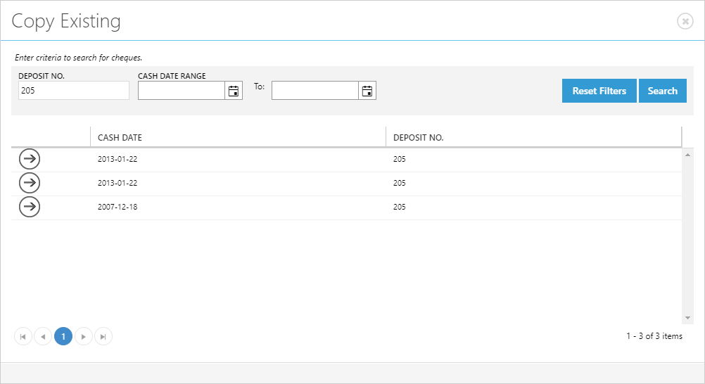

Selecting an existing payment line will display the next screen to view and confirm the new batch item(s):
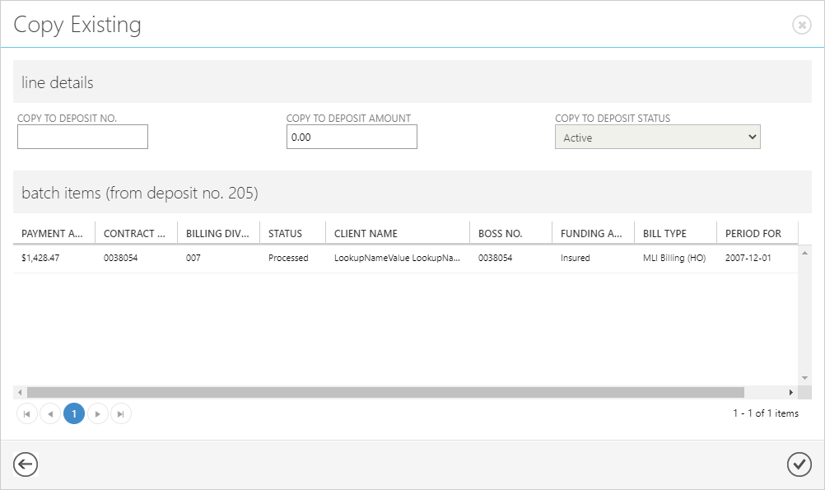

Copy to an existing payment line
Another way to use the copy existing function is to copy to a selected payment line. The difference is that the payment line is already there, with existing items.
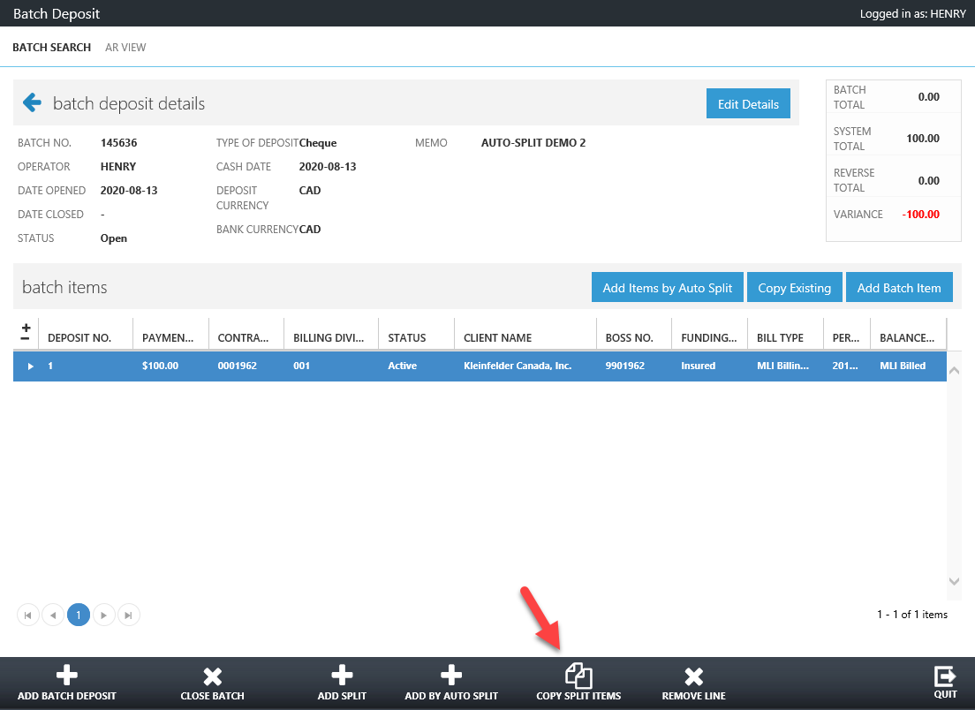

Payment amounts when copying an existing payment line
When copying an existing payment line, each batch item will have the payment amount set as 0.00. This ensures that the amounts are modified appropriately - variance validation is displayed to prevent incorrect payment amounts.

Add Items by Auto Split

Create a new line
A new batch deposit line with split items can be generated by the system using the "auto-split" function.
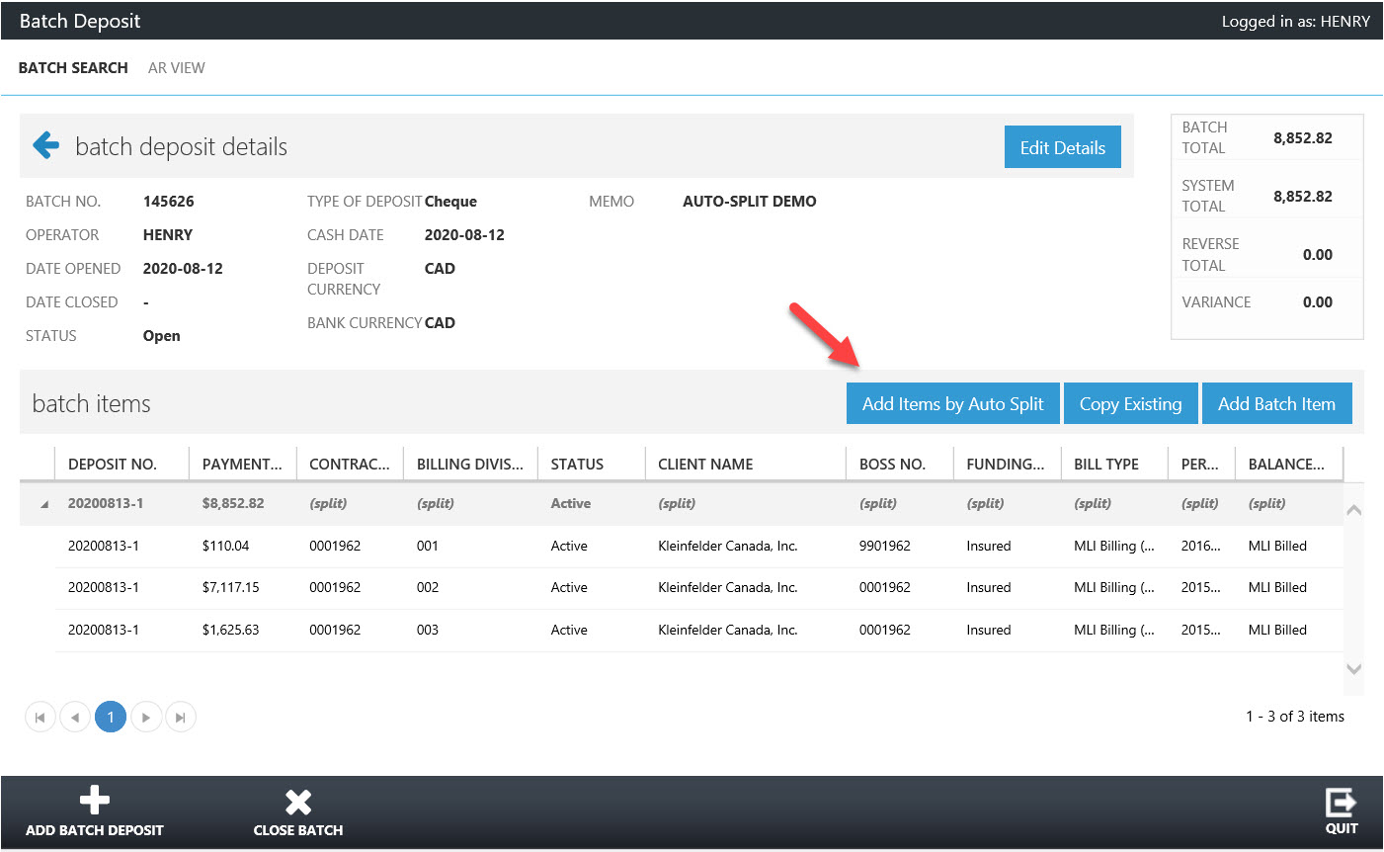

First, enter these information:
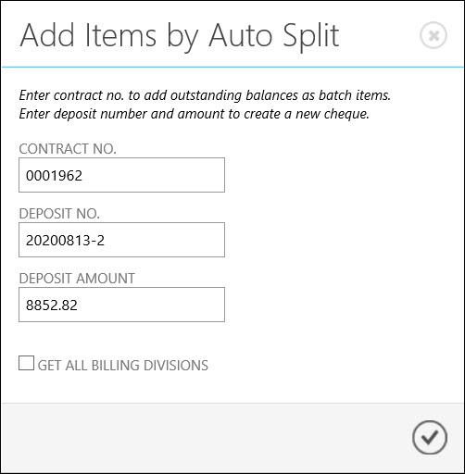
The system retrieves billing divisions based on the contract number provided. For each matching division a split line item is created with the account's current outstanding balance:
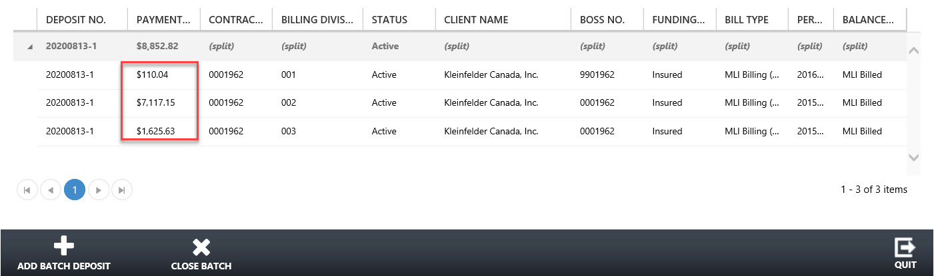

Add to an existing line
Another way to use the "add item by auto split" is to inject items into an existing line. In this example, there is an existing payment item for $123.45.
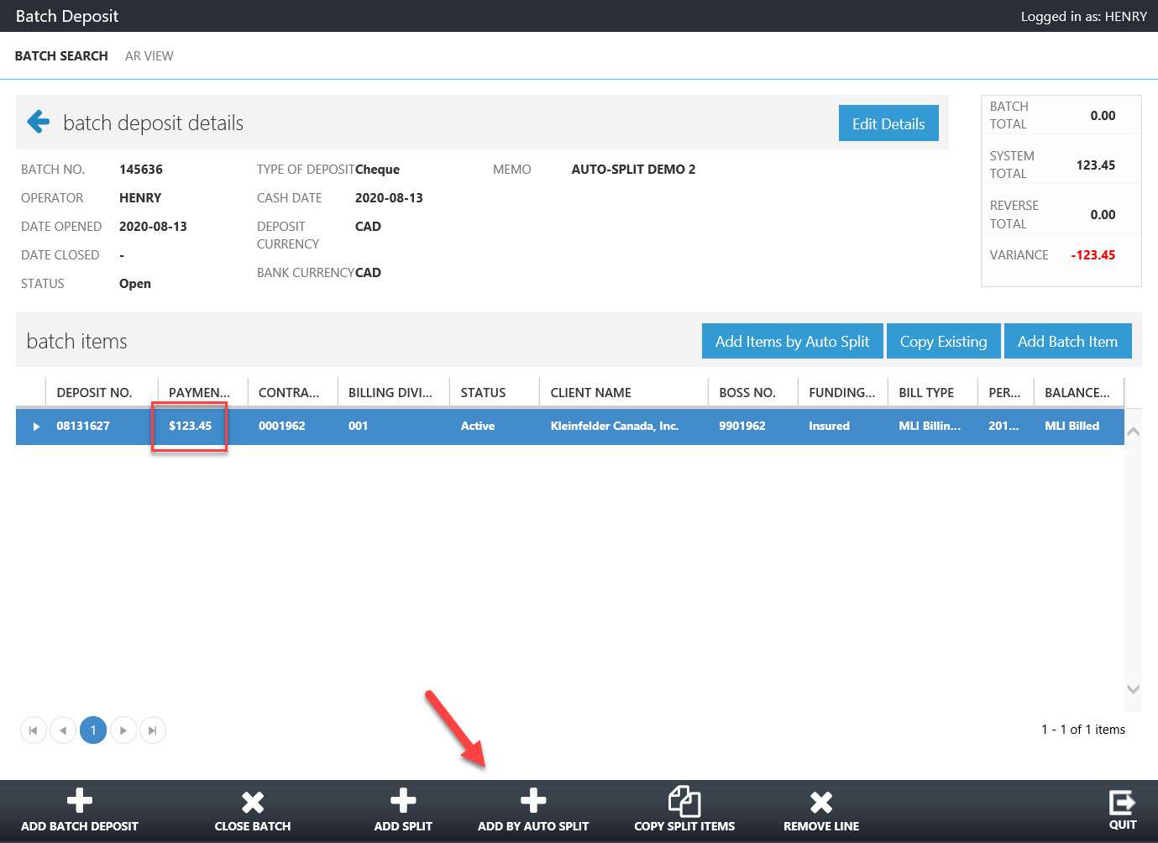

Select an existing line. All applicable functions toward this line appear on the bottom of the screen as buttons. Click on the ADD BY AUTO SPLIT button. Enter the contract no for the auto-split contents. Note that the deposit no. and amount are read-only at this point, because they are already entered to the existing line.
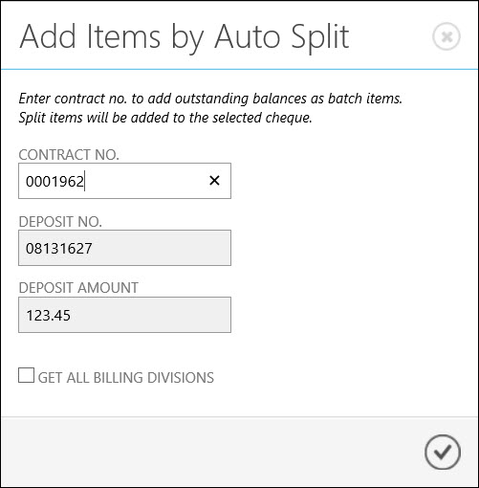

The system retrieves billing divisions based on the contract number provided. For each matching division a split line item is created with the account's current outstanding balance. Note that these items are added to the line in addition to the original item.
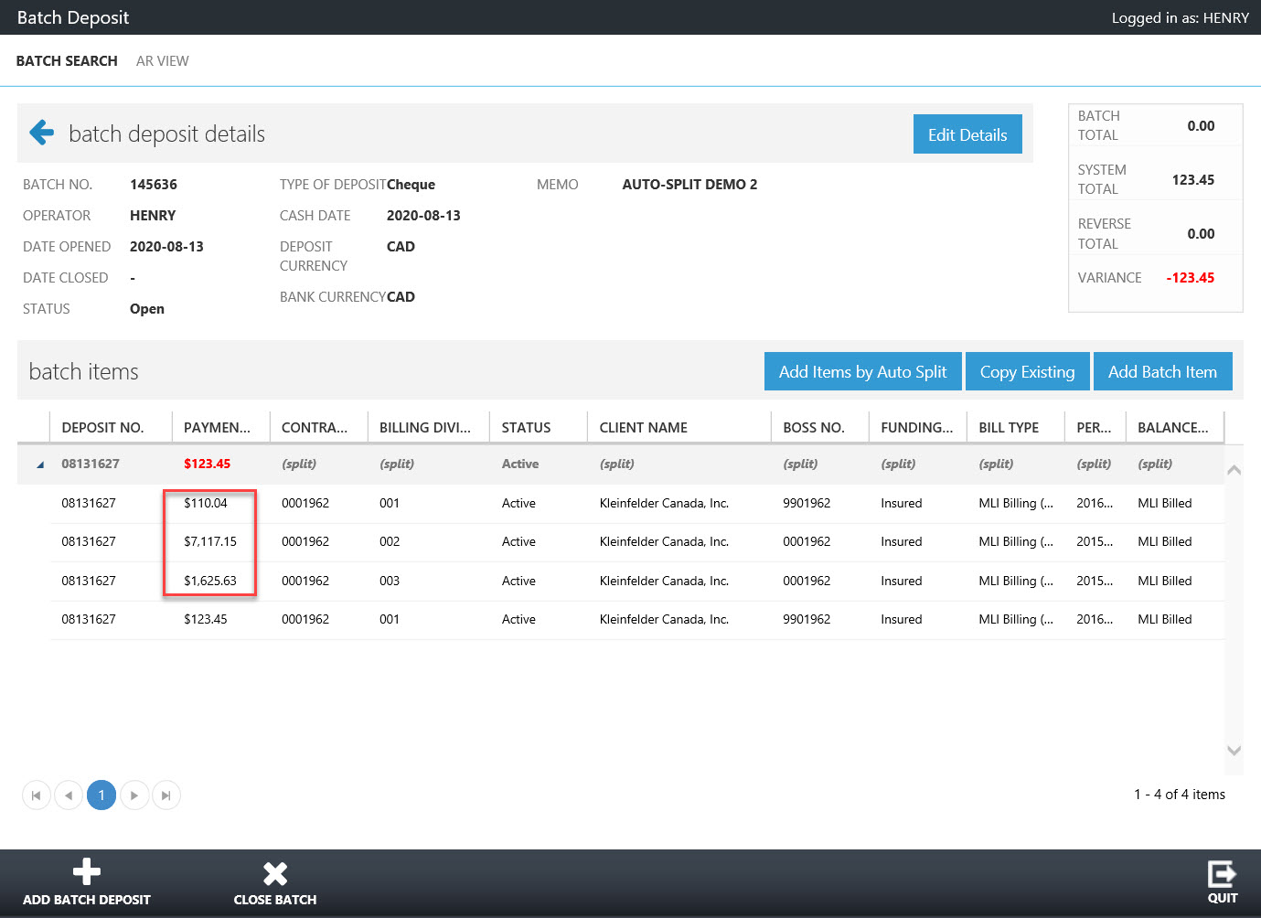

Working with Batch Items

Batch Item Variances
When a payment line contains one or many batch items, the total amount of the payment line should amount to the sum of all batch items.
In the following example,
- The second payment line contains one batch item (as it is not split) and the payment amount of the single batch item does not total the payment line amount, causing a variance of $25.00. The $25.00 is highlighted in red indicate that this amount is a variance.
- The first payment line contains three batch items (as it is a split payment) and the sum of the batch item payment amounts total the payment line. As there is no variance, the $50.00 is not highlighted.

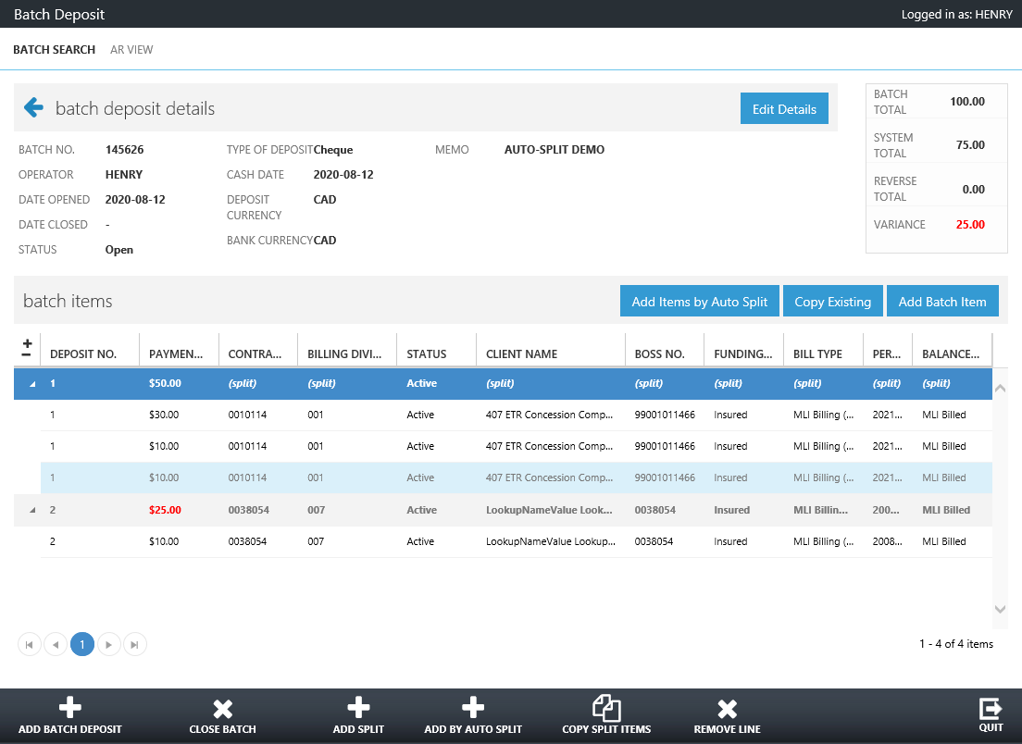

Payment Line and Batch Item Actions
When a payment line is selected, the following actions can be performed:
Add Split | This allows a payment line to be split (if not already) by displaying the "Add Batch Item" screen using the selected payment line. This action is only available for active payment lines.
Add by Auto Split | Similar to "Add Items by Auto Split" in the above. The difference is that here the auto-generated items are added to the selected line, with existing split items.
Copy Split Item | This allows a payment line to be split (if not already) by display the "Copy Existing" screen. Multiple batch items will be added to the payment line if the searched payment line is split. This action is only available for active payment lines.
Remove Line | This allows removing a payment line including any batch items. This action is only available for active payment lines.
Reverse | Allows reversing of payment lines when the status is processed.
Reallocate | Allows reallocating of payment lines when the status is processed.

The following actions can be performed on a selected batch item:
Remove Item | This allows removing a batch item from the payment line. This is only supported by active payment lines that are split

Closing a Payment Batch

How to close a Payment Batch
- Open payment batches will display an action button to close the payment batch.
- An error message will display if trying to close a batch when there is a payment line variance found. The variances information will be displayed and highlighted red in the upper right calculation section.

What happens when a Payment Batch is closed?
- Each payment line will be processed unless they are in the processed or deleted status.
- Each payment line item will be processed only if it is active and has a valid account associated (account id > 0).
- Each valid payment line item will have a transaction created for the associated account. See the "Payment Line Item Transaction Fields" below for more transaction details.
- If successful, the payment line item status will be set as closed.
- If all payment line items are successful, the payment line status will be set as closed.
- If all payment lines are successful, the payment batch status will be set as closed.

Payment Line Item Transaction Fields
For each payment line item an accounting transaction is posted against the account when the batch is closed. The resulting accounting transaction contains the following data values:
SubCategoryId | If the payment line item payment amount is less than zero - and the payment line status is reallocated or reversed, "Reverse Refund" is used, otherwise "Refund" is used.  If the payment line item payment amount is greater or equal to zero, and the payment line status is active, "Cheque" is used, otherwise "Cheque Reversal" is used.
TransDt | Uses the current date and time.
TransStatusCd | Uses the "Allocated" status.
ChqDepositDt | Uses the payment batch cash date.
ChequeNum | Uses the payment line cheque number.
ChqStatusCd | If the payment line status is active, then "Good" is used.  If the payment line status is reversed or reallocated, the"NSF" is used.
MemoTxt | Uses the memo from the payment batch.
OrigTransactionAmt | Uses the payment amount of the payment line item.
TransactionAmt | If the payment batch deposit currency and the bank currency are the same, the payment amount of the payment line item is used.  If the payment batch deposit currency and the bank currency is not the same, the deposit currency and the account currency are used to determine the exchange rate and applied to the payment amount of the payment line item. If an exchange is not found, the payment amount is used.
FundArrangmtCd | Uses the AdminTypeCd of the Location.

AR View

Searching for Clients
When navigating to the AR View (found at the top of the page), you can search for Clients and view additional details once selected:
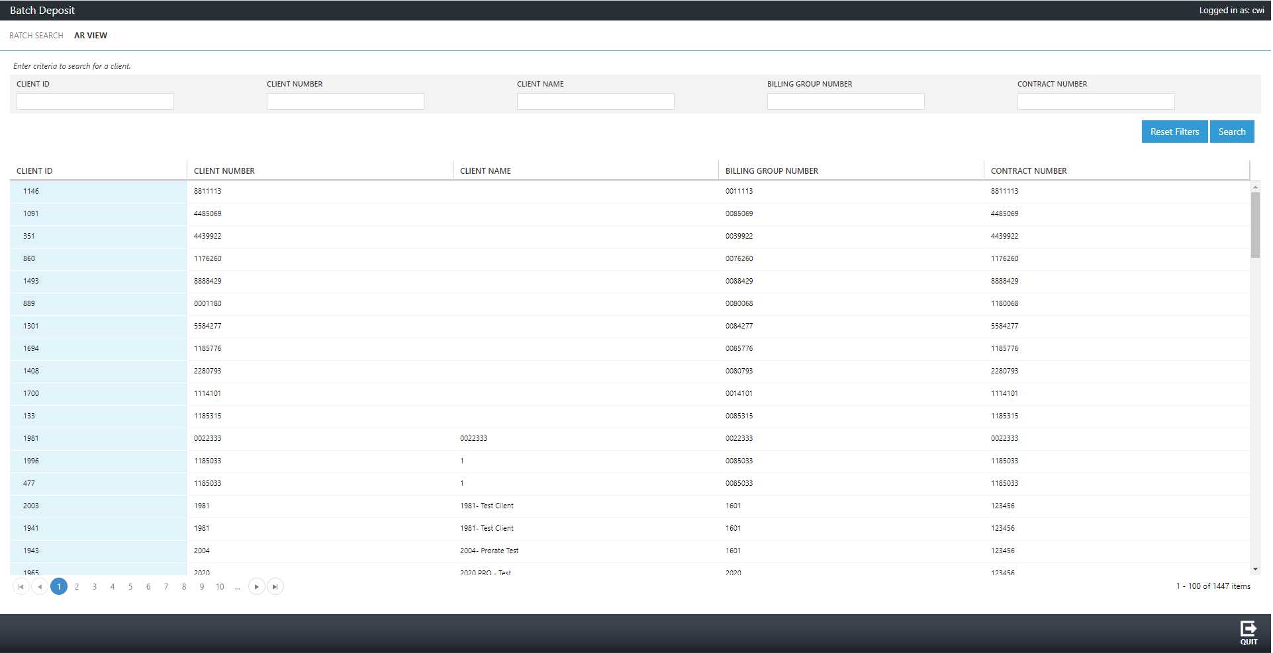

Viewing Client and Location Details
Selecting a Client will provide details of the Client and lists all Locations
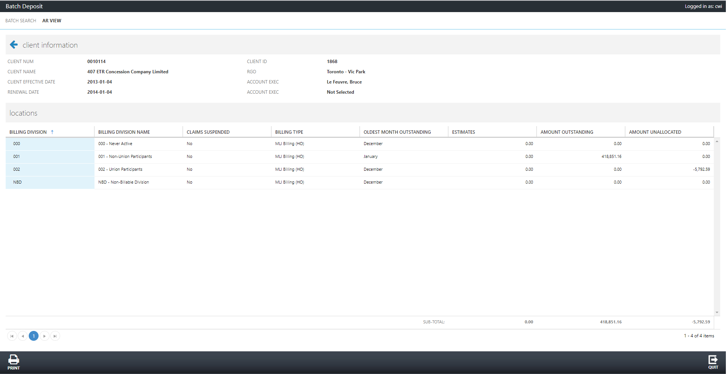

Selecting a Location will display additional details of the Location:
